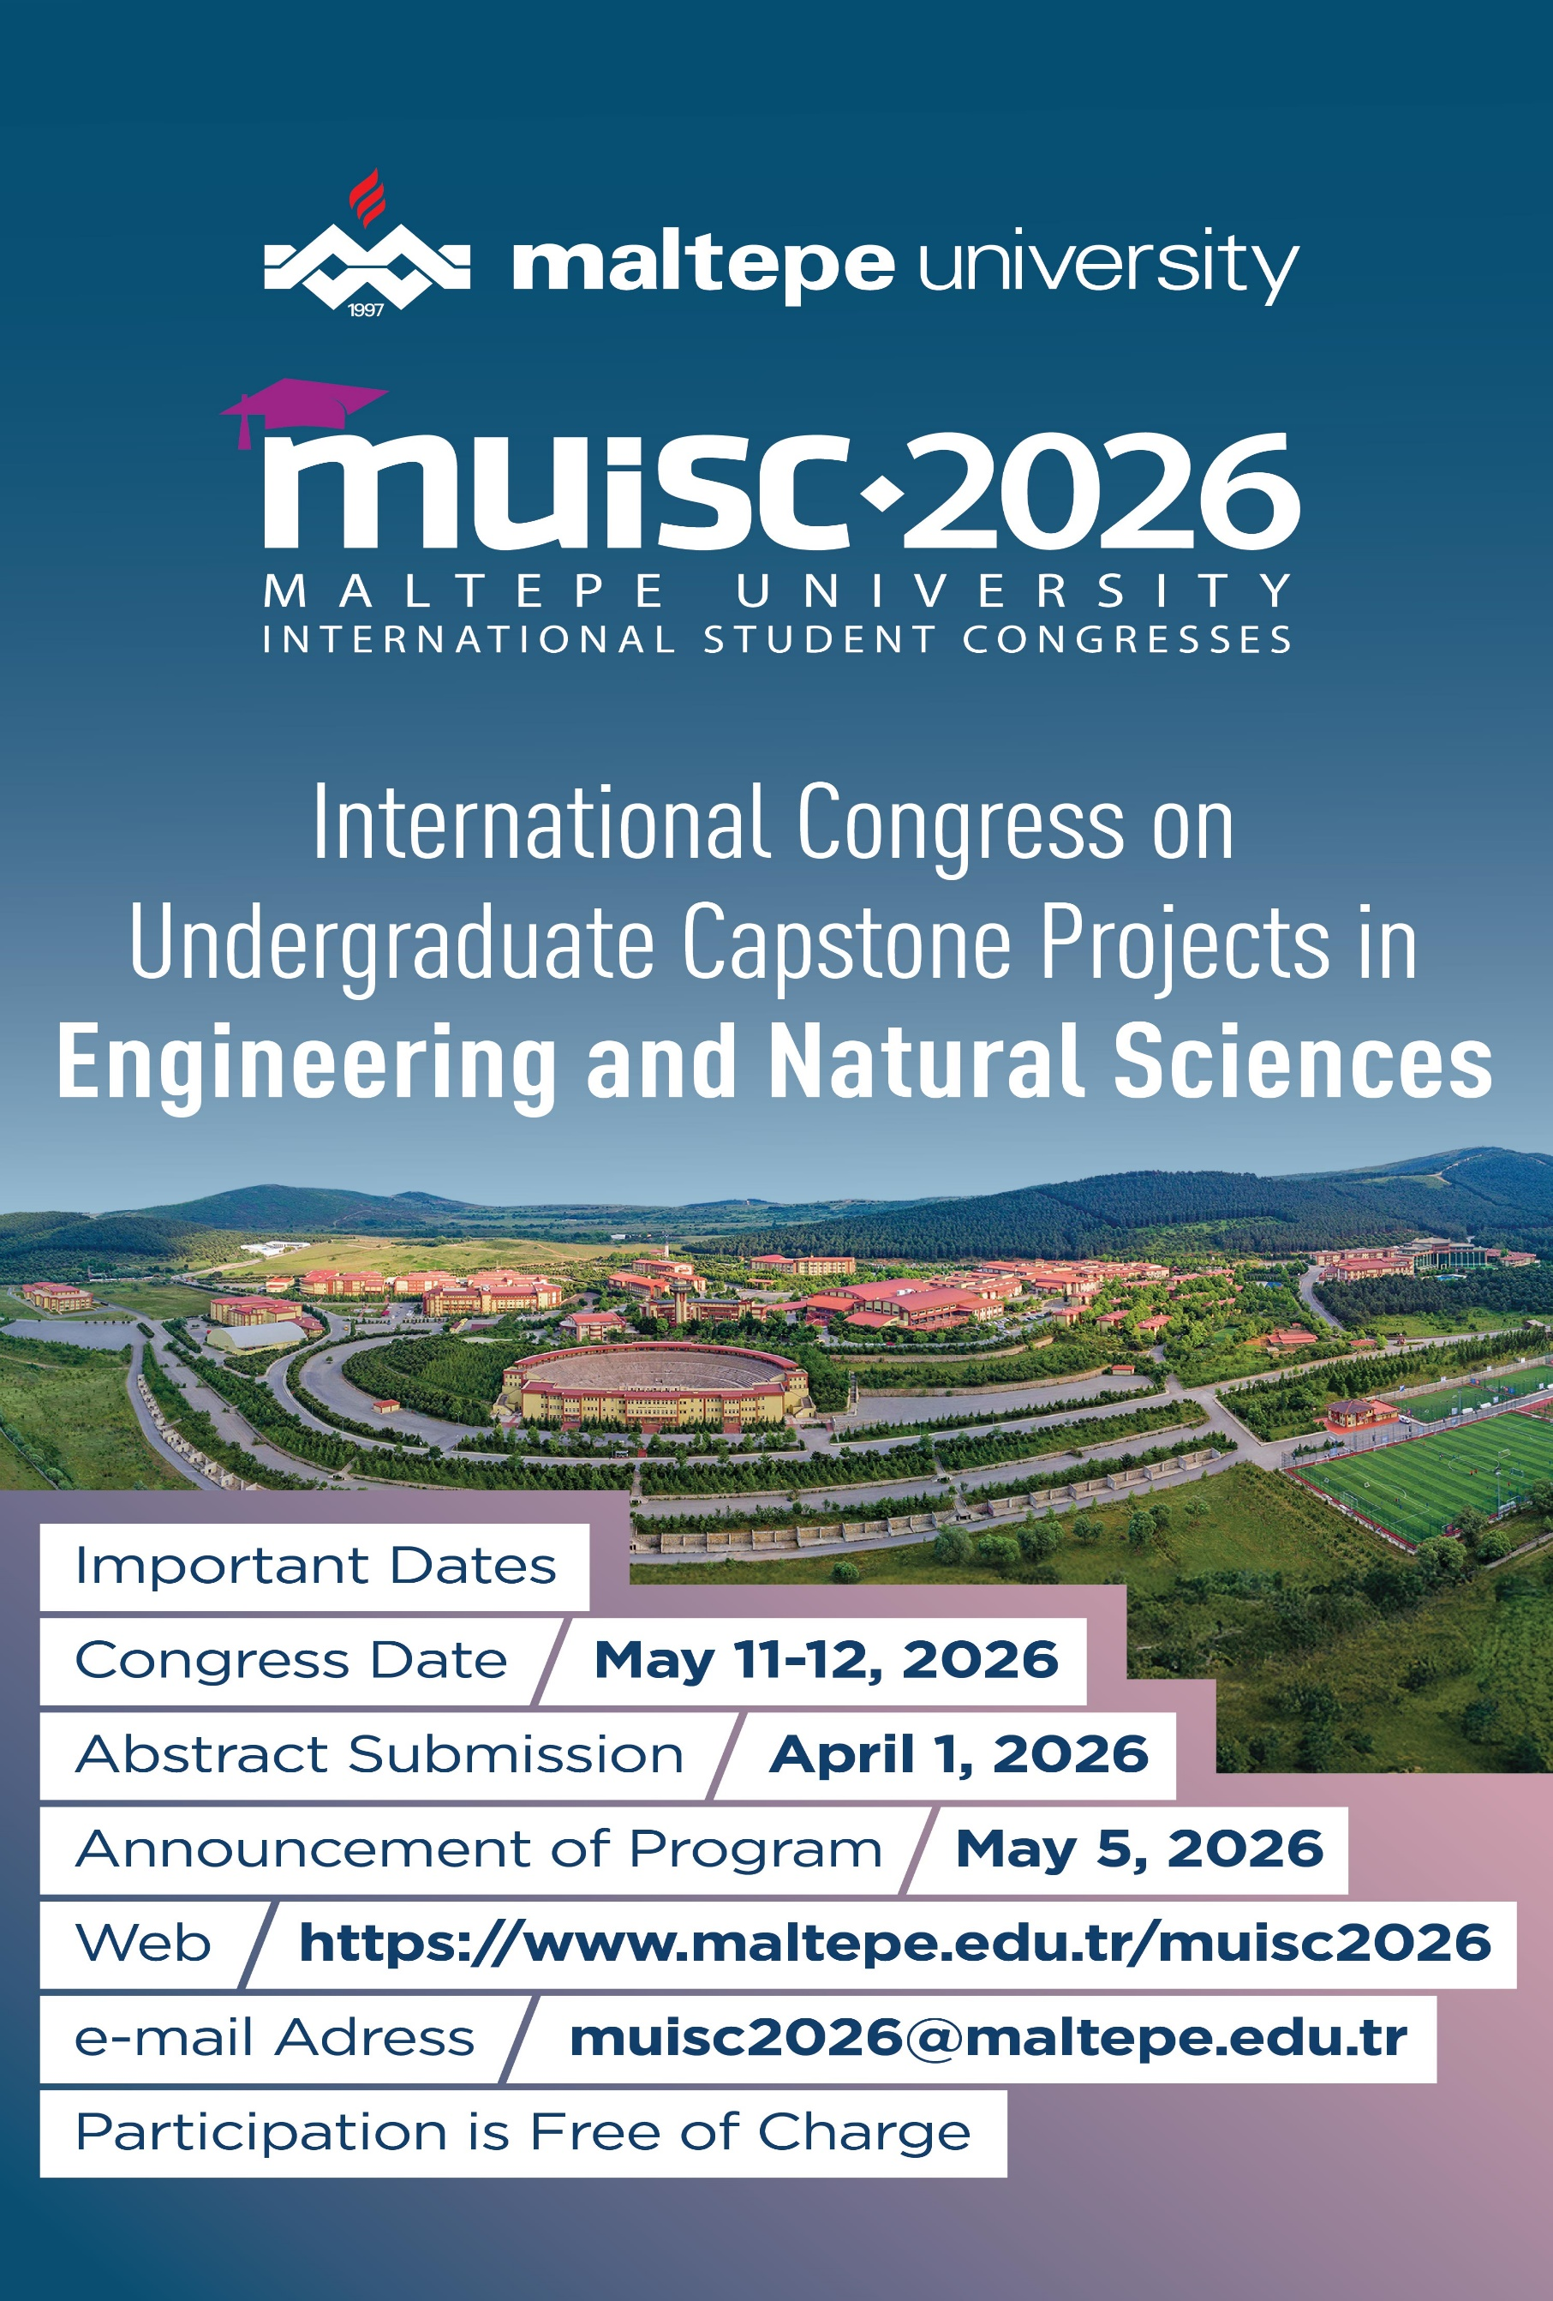

INTERNATIONAL CONGRESS ON UNDERGRADUATE CAPSTONE PROJECTS IN ENGINEERING AND NATURAL SCIENCES
Dear Academics and Students,
On behalf of the organizing committee, we are pleased to announce that the Maltepe University International Student Congress 2026 (MUISC 2026), titled “International Congress on Undergraduate Capstone Projects in Engineering and Natural Sciences,” will be held on 11–12 May 2026.
MUISC 2026 aims to provide an international academic platform for undergraduate students to present their Capstone Projects conducted within the fields of Engineering and Natural Sciences. The congress brings together students from different institutions and disciplines, offering them the opportunity to share their research-, design-, and application-oriented projects, receive constructive and critical academic feedback, and enhance their academic and professional competencies through interdisciplinary interaction. A key feature of MUISC 2026 is that all presentations will be delivered by undergraduate students, representing various departments and engineering and natural science disciplines. Through this congress, students are encouraged to synthesize the knowledge, skills, and methodologies acquired throughout their undergraduate education into comprehensive and integrative project outcomes.
The congress will be organized in a hybrid format, allowing both on-site and online participation, thereby ensuring broad international accessibility and engagement.
Brief information regarding the congress themes, submission guidelines, and important dates are given below. Undergraduate students are warmly invited to take part in MUISC 2026 and contribute to this international scholarly exchange with their Capstone projects.
Best regards.

CALL FOR ABSTRACT SUBMISSION
https://www.maltepe.edu.tr/muisc2026/en

Organized by: Faculty of Engineering and Natural Sciences, Maltepe University
Faculty of Engineering and Natural Sciences of Maltepe University will host the International Congress on Undergraduate Capstone Projects in Engineering and Natural Sciences in 2026, bringing together undergraduate students from around the world to enhance scientific interaction. As a significant part of the university’s International Student Congress (MUISC) series, this event aims to provide a dynamic platform where students can present their capstone, graduation, or senior-year projects, share innovative ideas, and engage in interdisciplinary dialogue within the fields of engineering and natural sciences.
Designed in a hybrid format, the congress will offer both online participation and face-to-face sessions on the Maltepe University campus, with no participation fee for undergraduate students. Projects from a broad range of fields -including engineering, natural sciences, applied sciences, and technology - are welcomed, and all accepted presentations will be published in an Abstracts Book with an e-ISBN. This congress represents a valuable opportunity for future engineers and scientists to showcase their work in an international setting and contribute to their academic and professional development.
IMPORTANT DATES
Abstract Submission Deadline | April 1, 2026
Notice of Acceptance/Rejection | April 17, 2026
Announcement of the Congress Program | May 5, 2026
Congress | May 11-12, 2026

